This is the last Note Home planned for November.
Please submit notices for the December newsletter by Monday, November 30.
Ushers: I would appreciate having the usher questionnaires returned to me before Sunday, November 29. Please leave them in the marked box in the church foyer (this coming Sunday the 22nd only), or mail in the self-addressed envelope that was provided. Thank you for helping with this important use. – Dandridge Cole
Thursday, Nov. 19 7:00 P.M. School Council Meeting. Addition Commons
Friday, Nov. 20 6:30 P.M. Holy Supper
Saturday, Nov. 21 11:00 A.M. to 1:00 P.M. Pumpkin Pie Pickup at KNC kitchen. (See below.)
Sunday, Nov. 22 9:00 A.M. Family Service. Indoor/Mask-Only. No singing.
10:00 A.M. Family Service. Indoor/Mask-Only. Singing. Live streamed.
Usher/Setup for 10:00 A.M. service: R.C. Storch
2:30 P.M. Resurrection Service: Suzanne F. Evans
Tuesday, Nov. 24 7:30 P.M. Arcana class (See below.)
Wednesday, Nov. 25 7:00 P.M. Bell Choir practice. Society Room
Thursday, Nov. 26 11:00 A.M. Thanksgiving Service
Chris and Heather Smith’s pavilion - 741 Old Philly Pike, Kempton
Ushers: Thos Powell and Doug Robertson
You are welcome to bring a fresh-, packaged-, or canned-food offering as an expression of gratitude to the Lord. In lieu of a procession, offerings can be placed on a table as you enter the service. We will contribute them to the Friend, Inc. Food Pantry in Kutztown, so your offering can be an expression of both love to the Lord and love toward the neighbor. If you bring fresh food, please be aware that it will still need to be in good shape six days later, which will be the next Food Pantry day at Friend, Inc.
Saturday, Nov. 28 4:00 P.M. Wedding at the Church: Linnea Heinrichs and Kendal King Special music starts at 3:30 P.M. Outdoor reception to follow. Please dress accordingly.

Sunday, Nov. 29 9:00 A.M. Family Service. Indoor/Mask-Only. No singing.
10:00 A.M. Family Service. Indoor/Mask-Only. Singing. Live streamed.
Usher/Setup for 10:00 A.M. service: Steve King
Monday, Nov. 30 Deadline for submitting notices for the December newsletter
Deadline for ordering Christmas Wreaths
Tuesday, Dec. 1 7:30 P.M. Pastor’s Council meeting. Addition Commons
Wednesday, Dec. 2 7:00 P.M. Bell Choir practice. Society Room
Thursday, Dec. 3 6:00-9:00 P.M. Ladies make wreaths at Char and Brandon Jungé’s barn
Friday, Dec. 4 2:00-9:00 P.M. More wreath-making at Char and Brandon’s barn
Saturday, Dec. 5 10:00 A.M.-12:00 P.M. Kempton Craft Sale
In the evening. A Christmas Sing, tentatively. Outside at Chris and Heather Smith's pavilion. Stay tuned for more details! – Joyful Music

Very Warmest Condolences: As reported with much sadness earlier, Suzanne Evans passed into the Spiritual World on Saturday, November 14. We are sending our love to Rich and the whole family, wishing them the Lord’s own peace however He may see to provide it – now, and over time. In my Father's house are many dwellings: if it were not so, I would have told you. I go to prepare a place for you. And if I go and prepare a place for you, I will come again, and receive you unto myself; that where I am, there ye may be also (John 14:2-3). A resurrection service for Suzanne will be held at the church this Sunday, November 22, at 2:30 P.M.

How to Help: If you would like to help with refreshments for the reception that will follow the service for Suzanne, please contact Erika Brown, who is coordinating the food for that. Amongst other jobs, a volunteer is needed to make coffee prior to the service.
Picking Up Your Pumpkin Pies – a change of date: If you ordered a pie to support our KNC fundraiser, please come for it at the KNC kitchen on Saturday the 21st between 11:00 A.M. and 1:00 P.M. (not on Sunday, a change due to church services). Thank you for your attention to this! – Mark Wyncoll P.S. If you need a delivery, text or call me.

Arcana Class: 7:30 P.M., Tuesday, November 24. AC Nos. 9363-9401. These teachings begin with a section from the Doctrine of Charity and Faith on the subject of Faith by Persuasion, and are followed by the explanation of the internal sense of Exodus 24:1-8, which describes the preparation for Moses to go up Mount Sinai and receive the ten commandments on the tables of stone from Jehovah. This chapter treats of the Word of the Lord and how it is Divine in both the literal sense and in its internal sense, and the use of both senses in the life of man.
Location: I will be doing a Zoom session in the library. If you want to join in person, we may need a larger venue, so please let me know beforehand. I'll send out a Zoom link the day before and also try to call around before the class. Zoom lets you join by phone as well. Hope you can make it to class. – Andy
The New Church Translation of the Sacred Scripture – the books have arrived. Thank you to those who have been expressing interest in acquiring one. Unfortunately, due to several glitches, we will not be able to take orders until after this coming Monday, November 23. We plan to have books for sale at the Kempton Craft Sale on December 5. If you prefer to order by phone, please call Jennifer Cole (the KNC office can give you her number). Please do not use the previously advertised website to order; corrected information about that will be shared later. Apologies for not being able, at this moment, to advertise the exact price of these cloth-bound books, which we expect to be in the range of $35-$40. Thank you – Members of the Kempton Project
Justin and Anndwyn’s Correct Address: We published the wrong address last week. For the right one, please contact the church office.
Kempton Craft Sale: Happening just over two weeks from now! Come do some Christmas shopping and enjoy the festive atmosphere. We will also be selling hot beverages, breakfast, and take-home soups to support the church. There's still time to be a crafter ($5 donation for adults, kids free); just contact me. A reminder: Set up for crafters will start at 9:30 A.M. so they can be ready at 10:00 A.M. – Kit Cooper
Remember to Order Christmas Wreaths to Support the Church and School! By Monday, Nov. 30!
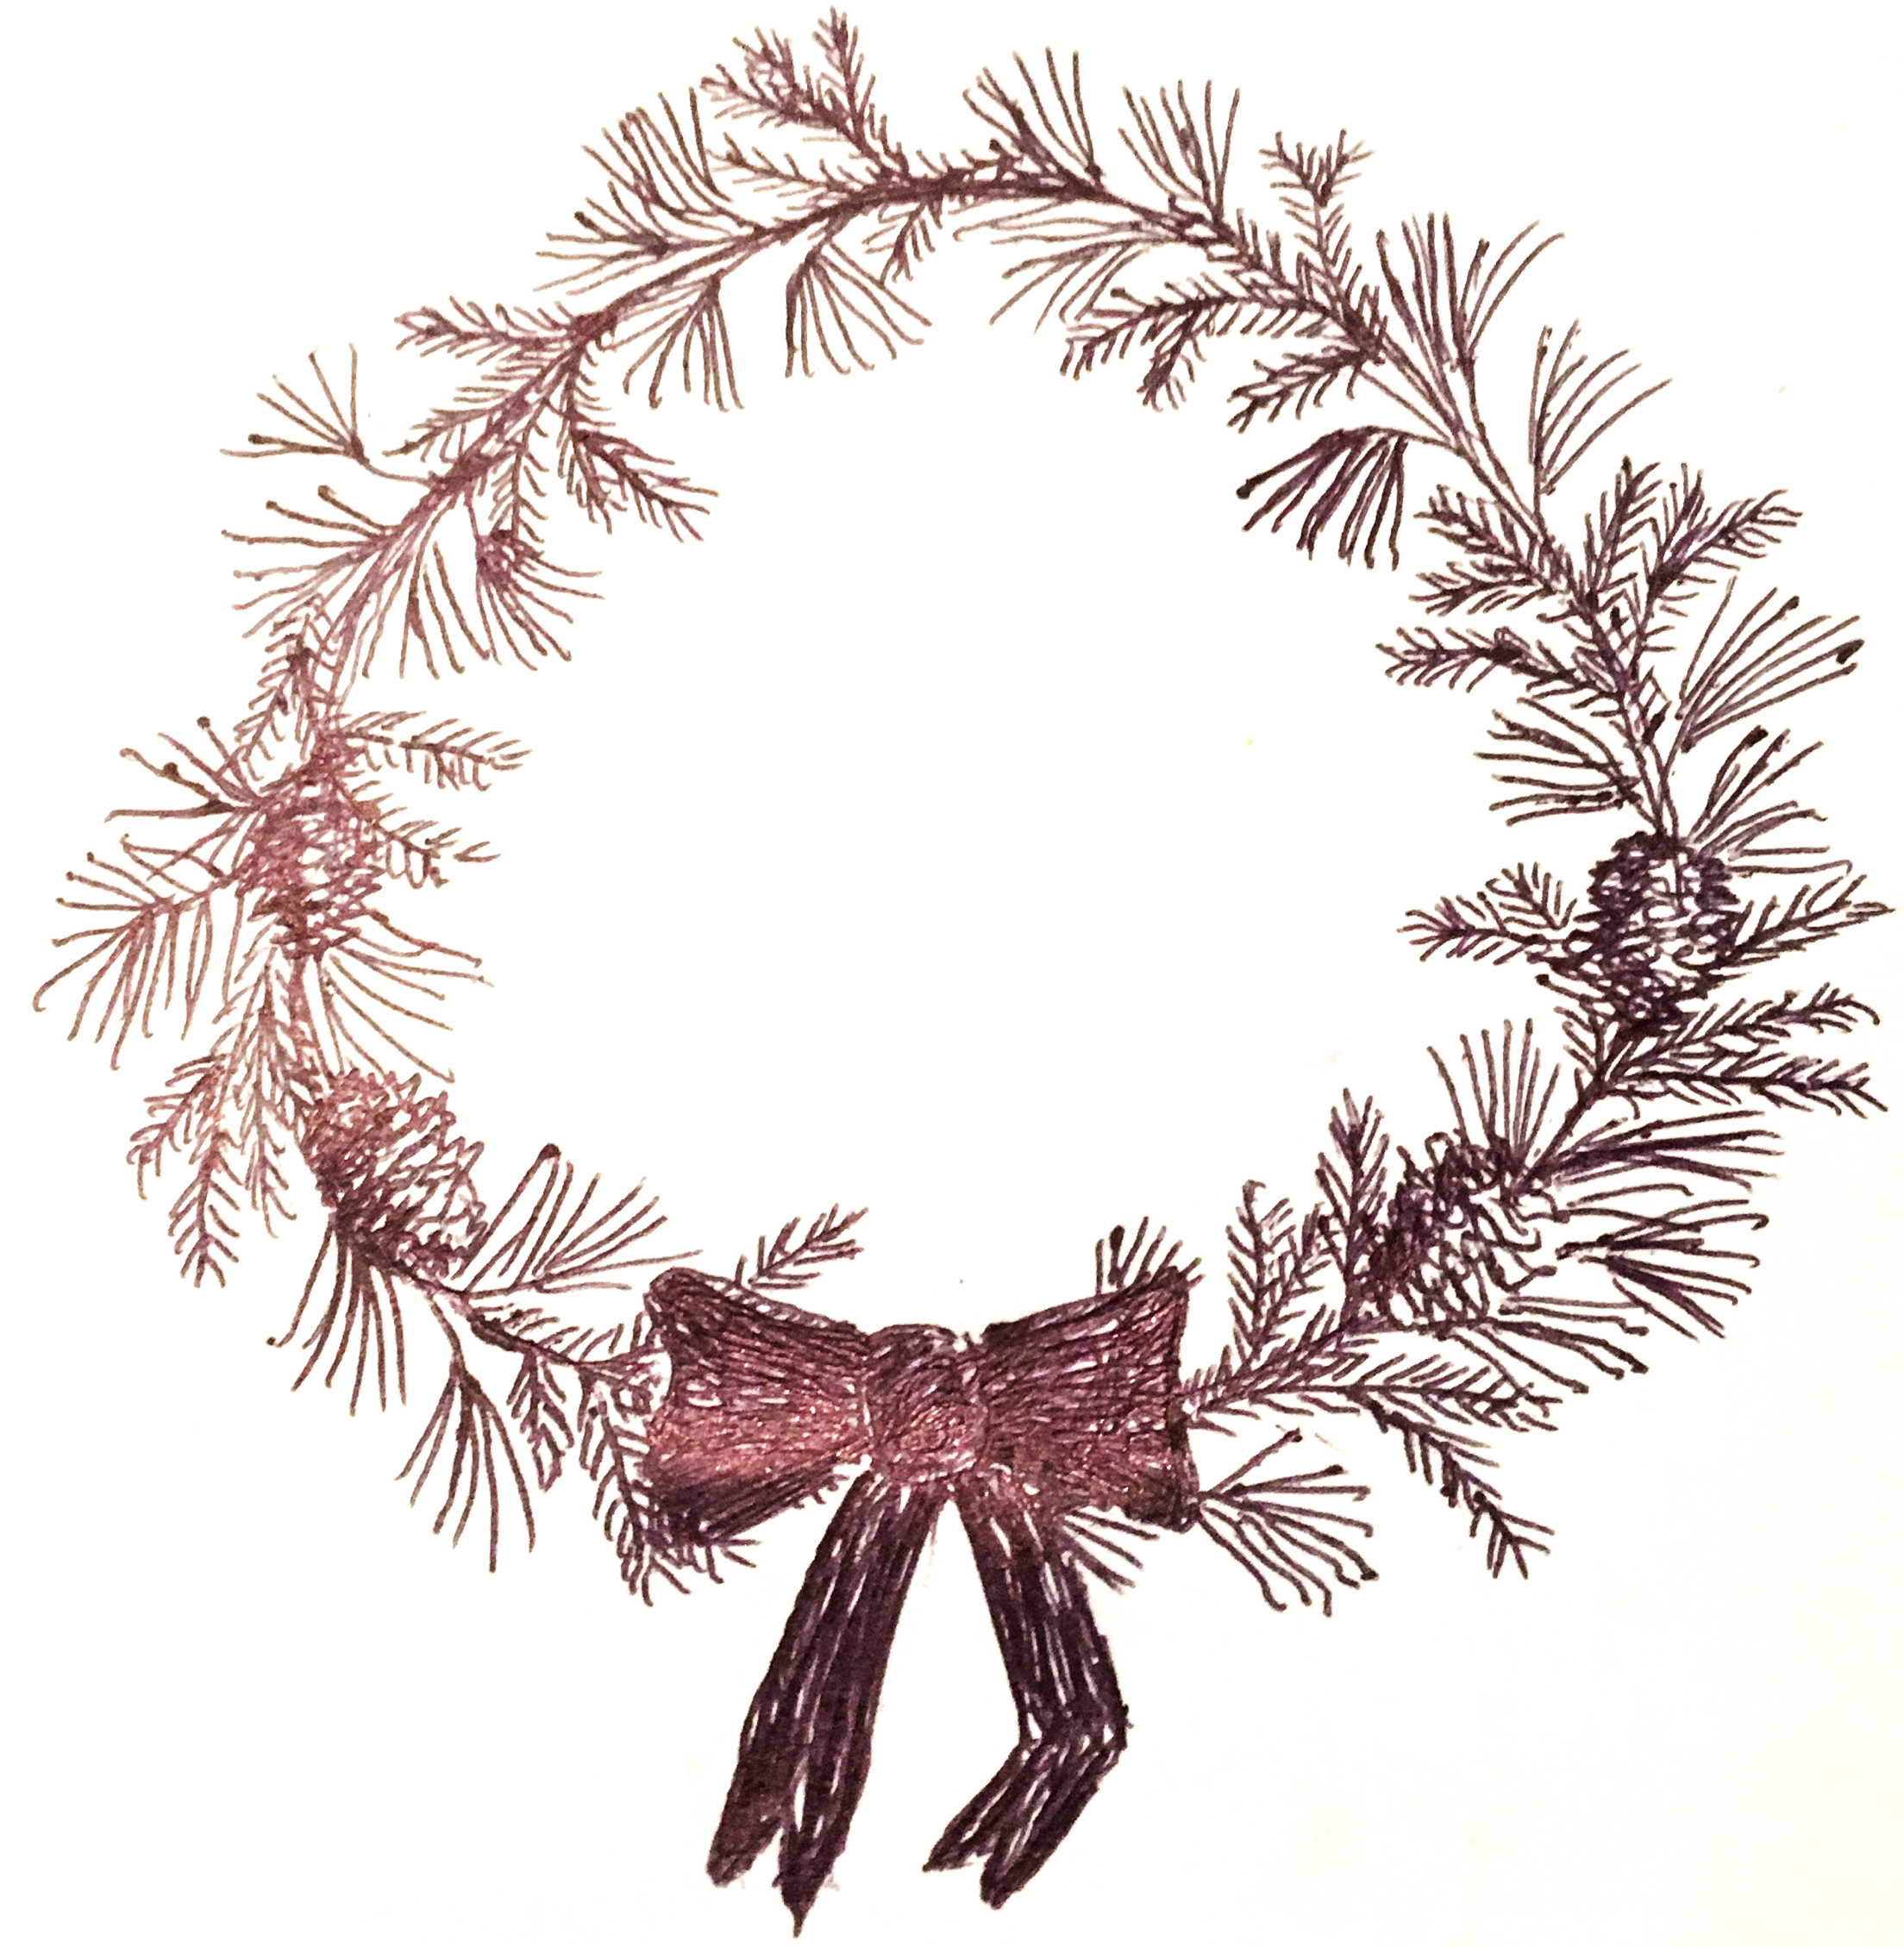
Please call Nancy Odhner to order. Large is $25. Small is $15.
Ladies are Still Invited to Make Wreaths! To support our fundraiser. At Brandon and Char Jungé’s barn. Thursday and Friday, December 3 and 4. See calendar above for times.
Call with any questions! – Katrin Jungé
Children’s Books Available at the Craft Sale: Come browse a collection of over 160 titles ranging from household classics to the rare and out of print. For the past several months, I have been hunting down and collecting used copies of many of my all-time favorite children’s books with plans to sell them in the future. With Christmas approaching, I decided to make the collection available at the craft sale on December 5th. A good book can serve as a wonderful gift or a fine companion for the winter months! I am excited about this collection and hope you will be too! – Genta Hendricks
Bryn Athyn Ladies Seeking Recipes for Pandemic-Inspired Cookbook: Inspired by the events and struggles we all faced this year, the ladies of the Bryn Athyn community have joined efforts to put together a cookbook, a collection of recipes gathered from the kitchens of our families, friends and neighbors. If you would like to share one or more of your battle-tested recipes, please contact BACookbookLadies@gmail.com, and we will provide you with instructions. Submissions must be received by no later than Tuesday, December 1. Cookbooks will go on sale approximately one month after the recipes are finalized (details to follow). All proceeds will benefit a local charity. Thank you – Erika Lee Synnestvedt, Organizer, Bryn Athyn Cookbook Ladies

