Friday, Nov. 13 7:30 to 10:00 P.M. Youth Group Conjugial Love class. Bonfire to follow. Buicks’
Sunday, Nov. 15 9:00 A.M. Family Service. Indoor/Masks-Only. No singing.
10:00 A.M. Family Service. Indoor/Masks-Only. Singing. Live streamed.
Usher/Setup for 10:00 A.M. service: Paul Schorran
Wednesday, Nov. 18 7:00 P.M. Bell Choir practice. Society Room
Thursday, Nov. 19 Please contact Brett by noon if you would like to take the Holy Supper on Friday.
7:30 P.M. School Council Meeting. Addition Commons
Friday, Nov. 20 6:30 P.M. Holy Supper. Please contact Brett by noon on Thursday if you would like to partake.

A Holy Sacrament: Annette Beatrice Buick was baptized on Saturday, November 7. Hear, O Israel: The Lord our God . . . is one! You shall love the Lord your God with all your heart, with all your soul, and with all your strength. And these words which I command you today shall be in your heart. You shall teach them diligently to your children, and shall talk of them when you sit in your house, when you walk by the way, when you lie down, and when you rise up (Deut. 6:4-7).
Warmest Congratulations: A boy – Levi Jonnie – was born to the Longs this week. Little lamb, we welcome you! May you thrive in every way as the Lord guides your path through life. He will keep thy soul. The Lord will keep thy going out and thy coming in…for evermore (from Psalm 121).
Food for Friends: Would you like to take a meal to the Longs while Levi Jonnie settles in? Contact the church office or Kit Cooper for how to access the meal schedule.
A New Church Translation of the Sacred Scripture:
Each word in the Sacred Scripture is like a precious stone given to us by the Lord, each phrase and verse is like a jewel. The words are beautifully arranged to reflect and transmit the light of heaven from within. The more a translation reflects this arrangement and beauty, the more the glory of the Lord can be seen. A translation faithful to the original text in the light of the Heavenly Doctrine can more perfectly convey what the Lord has revealed to man.
The editors of the Kempton Project here offer a revised translation of the Sacred Scripture for the New Church. We have reworked the text carefully and thoroughly, keeping in mind the fullness, holiness, and power by which the Word serves to conjoin heaven and earth, and both with the Lord.
The size of the book is smaller than the 2011 edition, at 1½″ thick and 7″ x 9″. This allows us to keep the large 13-point type that so many have appreciated.
This red cloth hardcover volume costs $35.00 US, plus shipping. We expect to make available a limited quantity of leather-bound volumes as well. Please check our website for pricing and other information -
https://kemptonproject.org/TheWord.
You can order through one of the following:
E-mail: TheWord@kncs.org
Phone: 1-215-938-8663
Mail: Kempton Project, 1050 Mountain Road, Kempton, PA 19529
We Miss the Hendrickses! Justin and Anndwyn, if you are listening, we think about you all the time and hope you are well in Germany. A family member reports that your children’s growth is apparent even on Zoom. 😊 Though snail mail may seem a thing of the past, the church office is happy to share it if you call.
Questionnaires are Being Mailed to Church Ushers for 2021: Please send your responses back to me before Sunday, November 29. Thank you for helping with this important use. – Dandridge Cole
Gratitude: Thank you to all our pumpkin pie supporters! Happily, we are sold out. The pies will be available for pick up on Sunday, November 22, at the KNC kitchen at 11:00 A.M. They are $12 each. Checks can made out to Kempton New Church. Enjoy! And thanks to our pie makers!
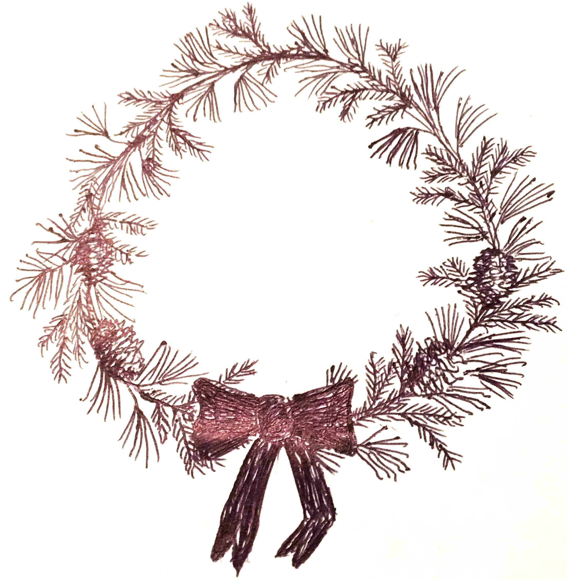
Christmas Wreaths for Sale to Support the Church and School!
Wreaths will be made with a variety of greens and decorated with pine cones (unless you prefer no cones).
Large is $25. Small is $15. You can pay upon your pick-up at the Kempton Craft Sale or upon our delivery to you.
To order, please call Nancy Odhner with the following information:
- Your name
- Size and number of wreaths
- Choice of ribbon color – red or gold
- Are you happy with cones as decoration?
- Will you pick up at the craft sale, or will we deliver to you?

Repeat Invitation to Make Wreaths: Ladies of the society are invited to make Christmas wreaths, which we will sell to benefit the church and school. If you've never made a wreath, don't be shy; it's easy to learn how. I have some extra clippers, but if you have your own, please bring them. Any time you can give would be wonderful!
Place: Brandon and Char Jungé’s barn – inside and outside
Times: Thursday, December 3 (6:00-9:00 P.M.) and Friday, December 4 (2:00-9:00 P.M.)
Hot Drinks: Provided!
Wreaths will be made to order. Any extras we produce will be available at the craft sale on December 5.
Any supplies or tips on where to find greens are still most welcome!
Call with any questions! – Katrin
Keeping the Kempton Craft Sale in Our Minds: Saturday, December 5, from 10 A.M to 12:00 P.M. Outdoors at Chris and Heather's pavilion (we'll have some fire pits, but dress warmly). Come find that special something for your loved ones this Christmas season! And support the church by buying some hot drinks, breakfast, or take-home soups. If you are interested in being a vendor ($5 donation for adults, kids free), please contact me. Thanks – Kit Cooper
Lost and Found: 1) Men’s short-brimmed green-brown soft grass hat with black band. 2) Pair of tiny black nylon gloves. 3) Navy blue lightweight pull-over hooded sweatshirt (Fruit of the Loom).

