Friday, Nov. 15 5:00 P.M. Baptism of Josephine Mae Lumsden. All are welcome.
Saturday, Nov. 16 10:00 A.M. Parents New-to-KNCS Class. Brett’s office
Return usher questionnaires to Dandridge Cole (or the church office) by this date.
Sunday, Nov. 17 10:00 A.M. Combined Service. Usher/Setup: Kenan Smith
Sunday School Teachers and Helpers: Nursery = Maraika & Lauren; 4 years-K = Elone & Marcela; 1st-3rd grades = Sarah Heiter & Garrett; 4th-6th grades = Heather
Deadline is today for Thanksgiving donations for the Northern Berks Food Pantry (being collected by Mesa Brown). See below for specific items needed. You can leave them at the school counter. Chandler Brown is collecting new socks for adults (for Christmas), which can also be left at the counter. Deadline for socks is Sunday, December 15.
Monday, Nov. 18 KNCS Ice Skating begins. See below.
Please contact Roxanne Genzlinger by this date if interested in joining a choir for church on December 8. See below.
Tuesday, Nov. 19 10:00 A.M. Moms Morning Class. Tovah Smith’s
Wednesday, Nov. 20 6:30 to 8:00 P.M. Bell Choir Practice
Thursday, Nov. 21 12:00 P.M. and 7:00 P.M. 7th and 8th Grades Play – Beauty and the Beast
Friday, Nov. 22 3:00-5:00 P.M. Kempton Fools’ Guild auditions. Society Room. See below.
6:30 P.M. Feast of Charity
7:45 P.M. Class: The Manuscripts of the Lord’s Second Coming
Saturday, Nov. 23 6:30-8:00 P.M. Kempton Fools’ Guild auditions. Society Room. See below.

We Have All Been Invited to the Baptism of Josephine Mae on Friday, November 15, at 5:00 P.M. Josephine was born to Eden and Derrick Lumsden just a week ago, so the angels could hardly be nearer. We most warmly welcome her.
Joyful Music is Getting Ready for the December 6 Christmas Sing. We will follow the tradition of years past by singing our favorite Christmas carols beginning at 6:30 P.M. At 7:30 P.M. we will take a break for snacks, live music, and celebrating the season together, giving families time to take small children home if needed. We will begin singing again at 8:00 P.M. We want this to be a fun-filled community event for all ages and abilities. Come for the cookie break even if you are a nervous singer! Drinks will be provided, but please bring a favorite Christmas snack or dessert to share.
KNCS Ice Skating Starts on Monday, November 18. Drivers, please be at KNCS by 10:20 A.M. Students will be returned to KNCS by 2:00 P.M. Weather permitting, skating days will be November 18 and 25; December 2, 9 and 16; and January 6.
Invitation to Decorate the Church for Our Christmas Eve Service: Would someone – or a couple of someones – like to be in charge this year? Please call Carla Kerr (610-756-6140).
[REPEAT] If You Would Like to Order Gift Cards for Christmas Giving (that will also benefit the school), you can look at shopwithscrip.com for the types that are available. I will need payment before I can place an order, and will need your order by the beginning of December to get them to you in time. – Loretta Alden
Parents Can Sign up for Weather Text Alerts from WFMZ – for KNCS Delays and Closings: Go to www.wfmz.com. Click on: 1) Weather, 2) School and Business Closings, and 3) Sign Up for Text Alerts. Then follow instructions.
Kempton Craft Sale: Crafters of all ages are invited to sell their wares at the Craft Sale on Saturday, December 7, from 10:00 A.M. to 12:00 P.M. The doors will open at 9:30 A.M. for crafters to set up. If you would like to have a table/spot ($5 donation for adults, kids free), please contact me. – Kit Cooper
Kempton Fools' Guild is Delighted to Announce that The Lion, the Witch and the Wardrobe Will be its 2020 Production! Auditions will be held in the Society Room on Friday, November 22, from 3:00 to 5:00 P.M. and on Saturday November 23, from 6:30 to 8:00 P.M. You do not need to prepare! You do not need to come to both times! You DO need to email or text me to say you plan on coming, and on which day. Please Note: There will be no speaking roles for those younger than fifth grade, with the possible exception of the role of Lucy. These non-speaking roles (available to all ages) do not rehearse until January! Performance dates will be in February. We hope you'll come and join us in Narnia! – Becky Cooper
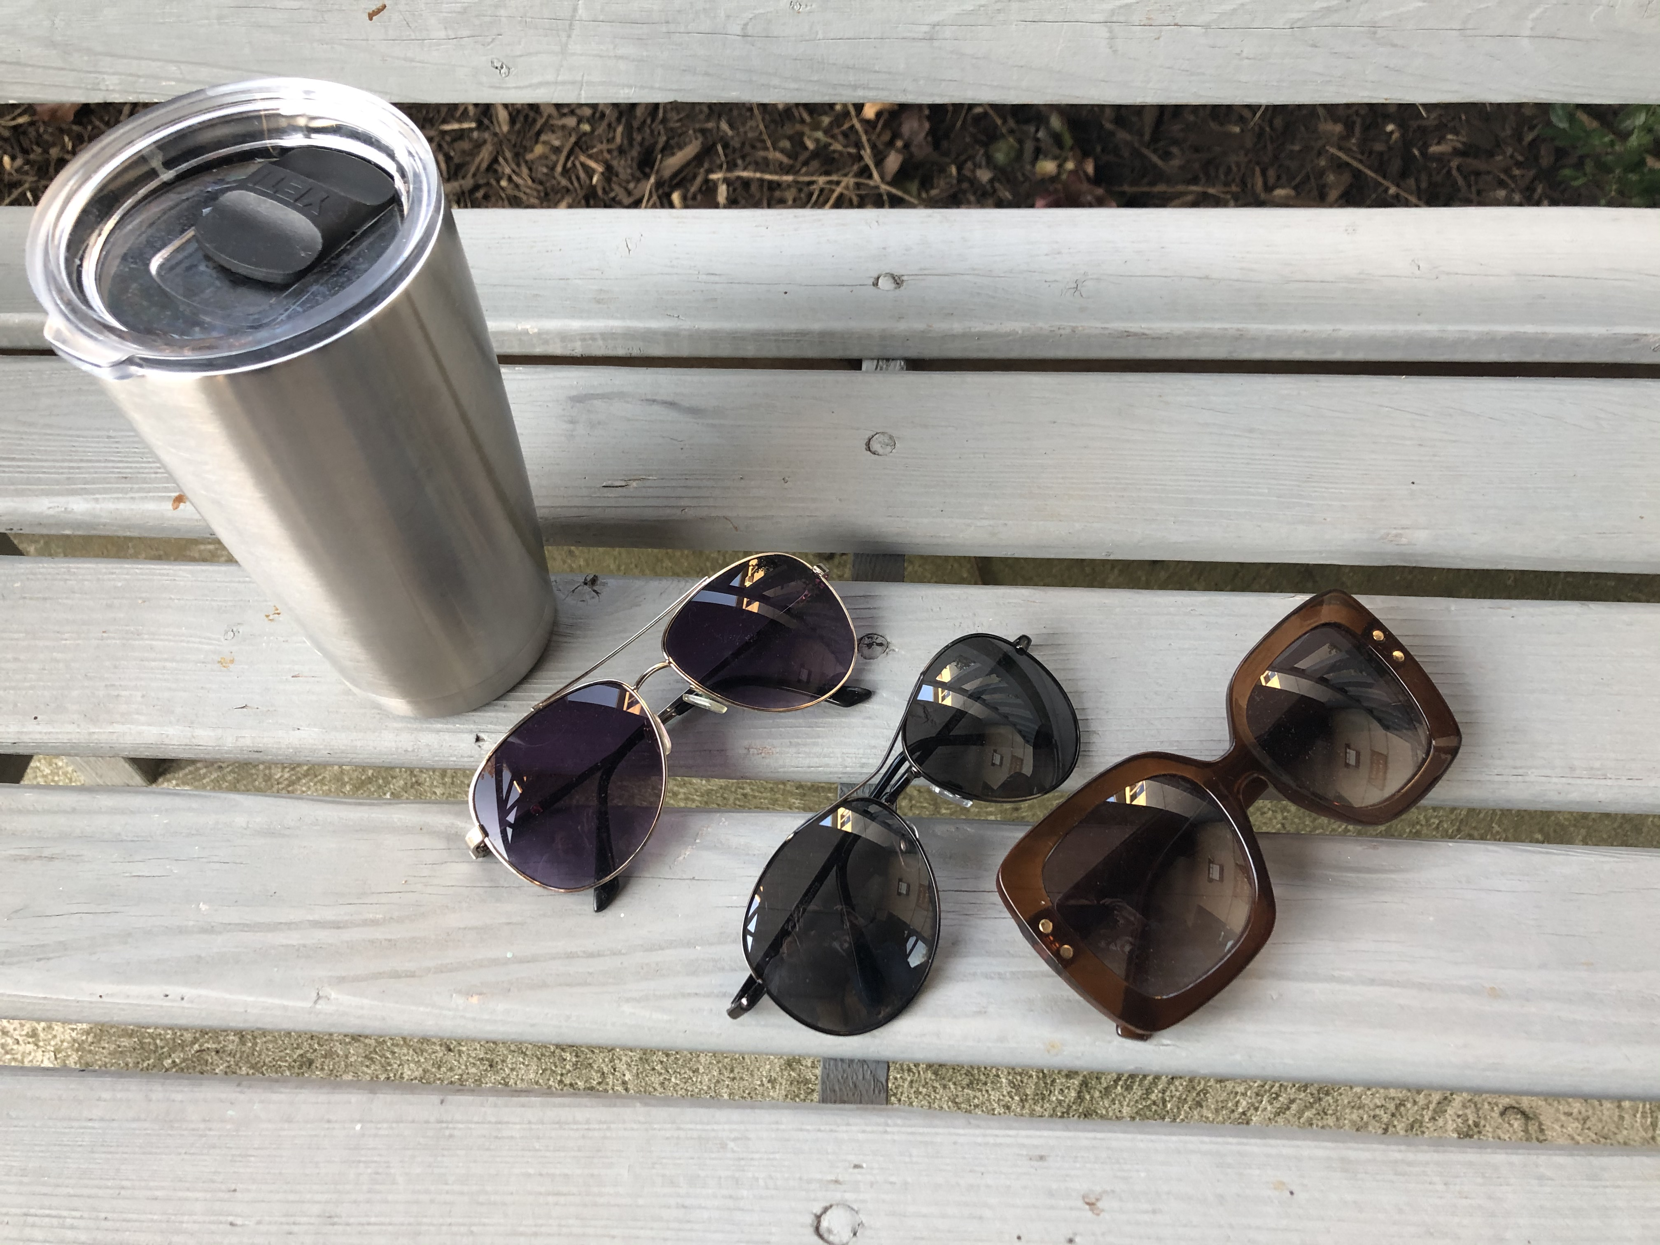
< In the Lost and Found: Silver Yeti travel mug, sunglasses. Call church office.
In Search of Pool Noodles for an Art Project (Felting Wool): You would not get them back, but the high school would much appreciate the gift. Please call or text me. Thanks – Heather
Contact Info: You can contact the church office to be given Gray Glenn’s new phone number.
Raffle Tickets to Support the Jake and Shannon Heiter Family: To win gift cards, purchase tickets at Rabert’s, Albrights Mill, and Deitrich’s Meats before Saturday, November 30, when drawings will happen at the benefit Hoe Down at the Virginville Grange.
[REPEAT] Help Us Share the Warmth This Holiday Season!
- Mesa (4th grade) is working with the Northern Berks Food Pantry to collect items for those who find joy in sharing gifts from their kitchen, but whose budget does not allow the staples many of us take for granted. Items needed for Thanksgiving: sugar, flour, baking soda/powder, vanilla, chocolate chips, raisins, nuts, sprinkles, brown sugar, 10x sugar, sweetened condensed milk, coconut, canned pie fillings, peanut butter cups, M & M’s, & Hershey Kisses. The deadline for those who’d like to help with this is Sunday, November 17.
- Chandler (7th grade) is collecting new, warm, men’s and women’s socks to donate to the Servants to All homeless shelter. His goal is to collect 100 pairs. This deadline is Sunday, December 15.
There is a collection box on the school counter, available for donations at any time. We invite you to support Chandler and Mesa’s efforts to spread holiday goodwill and cheer! Thank you – Michele Brown

Christmas Events in December

Friday, Dec. 6 6:30 P.M. Christmas Sing
Saturday, Dec.7 10:00 A.M. to 12:00 P.M. Craft Sale
Sunday, Dec. 8 9:00 A.M. Young Child’s Service – a silk marionette tableaux of the Christmas story, with readings from the Word. All ages welcome. In the school addition Commons. The service will start PROMPTLY.
10:00 A.M. Family Service.
Sunday, Dec. 15 10:00 ADULT Service (though children welcome)
4:30 and 6:00 P.M. Tableaux Services
Wed., Dec. 18 7:30 P.M. Society Christmas Doctrinal Class
Friday, Dec. 21 11:00 A.M. KNCS Christmas program, followed by two-week break from school
Sunday., Dec. 22 10:00 A.M. Family Service
Tuesday, Dec. 24 5:00 P.M. Christmas Eve Family Service
Wed., Dec. 25 Happy Christmas!
Sunday, Dec. 29 10:00 A.M. Family Service

