Sunday, November 4 10:00 A.M. Combined Service. Usher/Setup: Doug Robertson
Sunday School Teachers: Nursery / Anndwyn & Adele; 4 years-K / Katrina & Phoenix; 1st-3rd grades / Sheila & Jonah; 4th-6th grades / Shanon Smith; 7th-8th grades / Thaddeus
Meeting after church (11:30 A.M.) on school leadership
Monday, November 5 Parent/Teacher Conferences for Grades 7-12 in the afternoon
Tuesday, November 6 Picture Day at KNCS: Students, all teachers (part-timers too), and aides.
Parent/Teacher Conferences for Grades 7-12 in the afternoon
Wednesday, November 7 DATE CHANGE: School-Addition TRUSSES Installation begins today at
8:00 A.M., weather permitting (see below).
Parent/Teacher Conferences for Grades 7-12. Afternoon
Thursday, November 8 8:00 A.M. Installation of School-Addition Trusses continues, weather permitting. Stay in touch with Brandon (see below).
Friday, November 9 Parent/Teacher Conferences for Grades K-6. Morning
NO SCHOOL for Grades 1-6 this day
6:45 P.M. Feast of Charity (cooked up by Roger & Bengt!) 7:45 P.M. Doctrinal Class: The Unity of God

Our New Treasurer: On Sunday, October 28, the board of trustees elected Ian Keal as our new treasurer. Our many thanks go to Roger Schrock, our outgoing treasurer, for his years of dedication to this use. He will be introducing Ian to the job over the next few weeks and months. Many thanks to Ian, too, for taking on this position, serving the society. – Lawson
Meeting on Sunday the 4th about School Leadership: After church, at 11:30 A.M., there will be a meeting in the library especially for parents of children currently enrolled at KNCS. There will be babysitters to watch your children. The purpose is to discuss the concept of having the pastor no longer be the principal of KNCS.
Autumn Weekends: Thank you to all the great volunteers this fall, including those who helped with packing up all the stuff on our last day while it rained. We couldn’t have done it without you! We had great season, with revenue just shy of $15,000. We also would like to say that we will be the Admirals again next year and hope to have another great year! We are planning to have a post-Autumn Weekends meeting sometime later in November or in December, where we will talk about how the year went and share thoughts for the future (stay posted). Lastly, we have some leftover frozen food that will be for sale after church this Sunday at a discount.
On a different topic, the Halloween party was lots of fun, but along with A.W. it’s a little too much for us, so someone else could think about taking it over for next year. Feel free to contact us for information. Again, thanks for all your A.W. work! – Kit and Torrey, Admirals
News Flash: The Trusses Time has Been Changed. They are coming next Wednesday the 7th (the day before they were supposed to arrive). Sorry for the inconvenience for those who have shuffled their schedules to make time to help. My understanding is that we may be bumped again, especially if we get any bad weather between now and then. To repeat, any men or boys 14 years and up are welcome to show up any time that day. Please call in advance to confirm what is happening that day. (After hours office – 619-756-3551. During work day cell – 484-256-6226.) If you want to work, you have to bring date of birth and Social Security number. You will be paid minimum wage. In this way everyone will be insured. We plan to meet at 8:00 A.M. Oversize loads have to wait until dawn to get on the road, but with daylight savings they should not be far behind. See you there! Brandon over and out
Picture Day (Individual Photos) at KNCS - Tuesday, November 6: Mr. Schrock will be capturing the students on film [Mrs. Synnestvedt, you’re dating yourself] for the KNCS yearbook, smiles and all. We would also love to have any and all faculty and staff—including aides and part-timers—represented in our book, so they are invited to drop by the library around 10:00 A.M. (a bit before or after would be fine). Everyone try to be well and present! Thanks from Judy, for the Yearbook Club

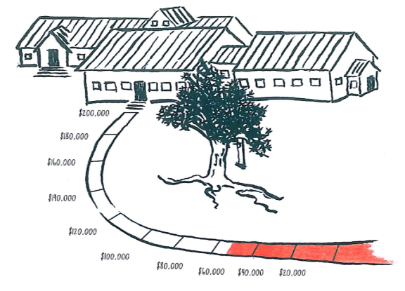

From the
SCHOOL EXPANSION
FUNDRAISING COMMITTEE

It looks like we have about $144,000 left to raise.

Thank you for your contributions!

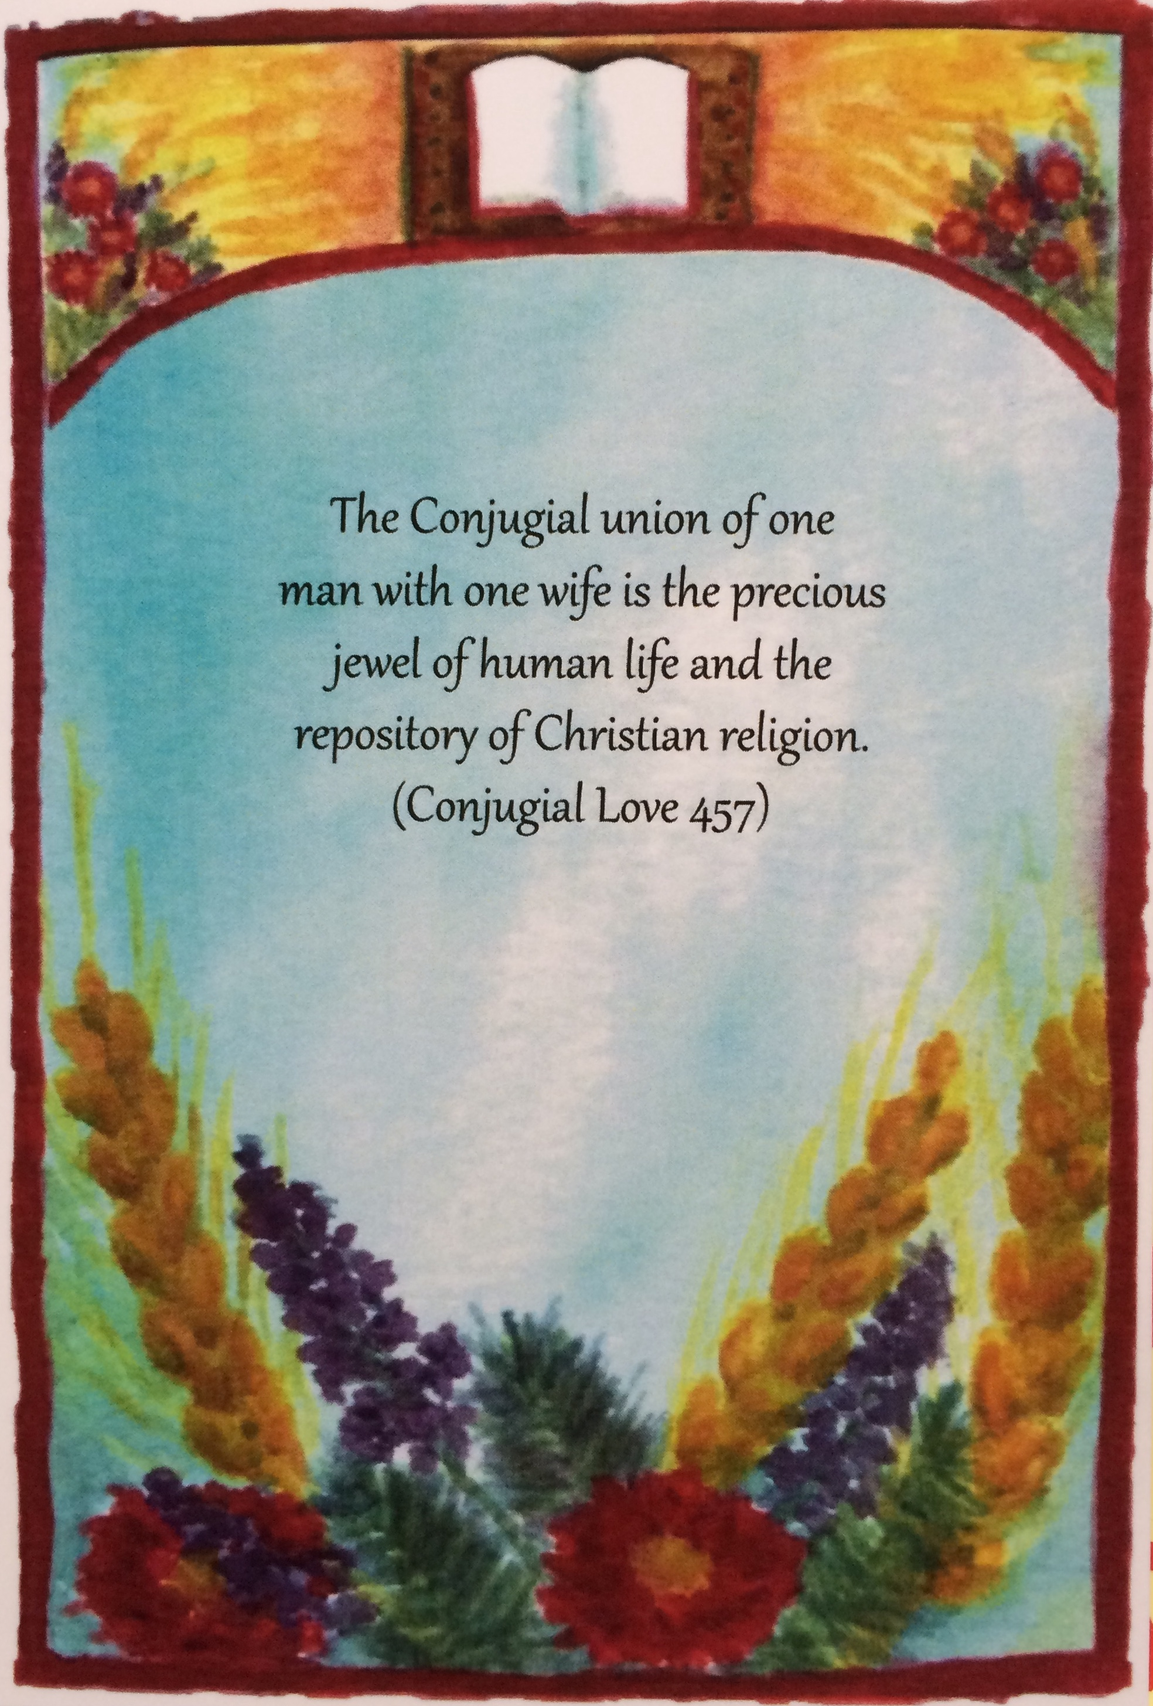
The honor of your presence
is requested at the marriage of

Liza Reneé Jungé
to
Calvin Bradley Heinrichs

Saturday, November 17th, 2018

Kempton New Church
583 Hawk Mountain Rd.
Kempton, Pennsylvania 19529

Special Music at 1:45 P.M.

Wedding at 2:00 P.M.

Reception and refreshments to follow

Spiral Garden Planning: In just a few short weeks, darkness will have set in upon us. As Advent begins and we look to the Lord for His light, we can light the Advent spiral with a candle and brighten the darkness. If you would like to help with or fund the spiral garden, please reach out to me (484-661-8999 or sheilly88@yahoo.com). There are many tasks, small to big, to be completed. “Thy word is a lamp to my feet, and a light to my path” (Psalm 119:105). Thank you – Sheila Heiter

“A Companion to Divine Love and Wisdom” by Rev. Prescott Rogers: Newly published (2018, General Church of the New Jerusalem). From book review by Rev. Christopher Barber, Religion Instructor at the Academy of the New Church: “How did creation come into existence? What is the life force that causes seeds to sprout or animals to produce offspring? What is the origin of evil? Is God to blame for it? How are spiritual experiences explained? The book Divine Love and Wisdom is a key work in building a New Church worldview…. This companion work by Rev. Prescott Rogers serves to make [it] more accessible to all readers, regardless of their background in Swedenborgian thought…. Like the master teacher he is, he gives us all a gentle nudge into our as-yet unknown.” Available at the Bryn Athyn Cathedral Bookstore (215-947-6225; Ext. 4922) or Amazon.com. ISBN: 978-0-945003-88-5, $12.95, 170 pages.
Kempton Fools Guild: We are ready to get started on “Anne of Green Gables”! Auditions: Friday, Nov. 9 (2:00-4:00 P.M.), and Saturday, Nov. 10 (2:00-5:00 P.M.), in the society room, with possible call-backs for principal characters on Nov. 11 (2:00-5:00 P.M.). If you would like to audition, please email me at rebecca.asc@gmail.com and indicate whether you would prefer Friday the 9th or Saturday the 10th. You will not be required to be there for the entire audition time. If you are unable to attend either of these days, please email to set up a separate time. You don’t need to prepare! Just show up and have fun. Portions of the script will be available upon request. Performance dates will likely be early March. See you there!
– Becky Cooper
Steph Eden (Latta) asks us to say that she’ll be performing at Stony Run Inn on Thursday, November 15, 6:00-8:00 P.M. Guest musicians may possibly be joining her. Either way, a treat. (Reservations strongly recommended.)
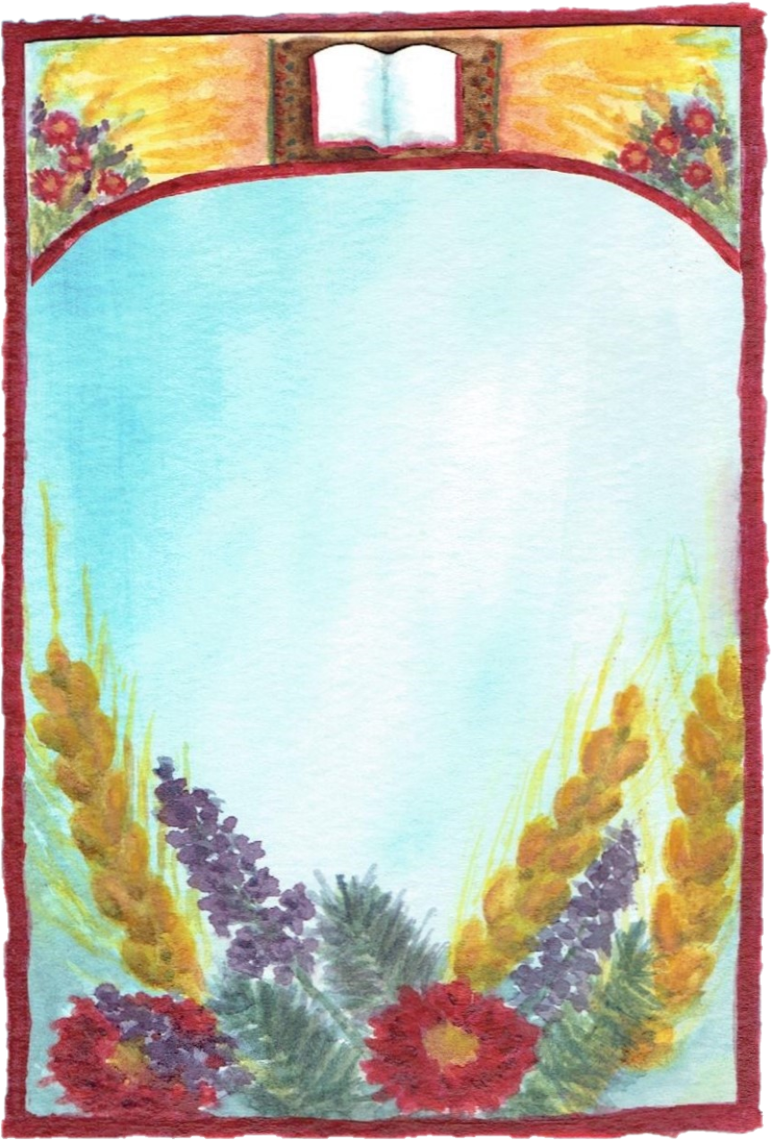
“Community of Historic Barns in Albany Township” – a talk and book signing by Greg Huber, author of “Historic Barns of Southeastern Pennsylvania”. Learn about the great differences and diversity of the surviving barns in our township. Friday, November 9, 2018, at 7:30 P.M. Allemaengel Room at the Albany
Township Historical Society, 404 Old Philly Pike, Kempton.

