KEMPTON NEW CHURCH NOTE HOME – March 9, 2017

Thursday, March 9 TONIGHT – 7:30 P.M., Society Room. Special Society Meeting to decide on an attached or unattached addition to the school
Saturday, March 11 Turn clocks ahead tonight.
Sunday, March 12 10:00 A.M. Family Service. Usher/Setup: Owen King.
Tuesday, March 14 7:30 P.M. Arcana class. Nos. 7969-8032. At Gale and Emily Smith’s
Thursday, March 16 7:30 P.M. Meeting for adults on protecting our children
A Heartfelt Thank You to all the people who helped make Wellesley’s memorial service happen. It was a beautiful service; we were so grateful for how it went. It involved so many tasks both big and small, and we could not have made it all happen with out the help from so many friends. Thank you all so much! Gratefully – the extended Keal Family
Dear Friends, The recent passing of Wellesley, who has a deep love of music, has inspired her friends and family to create a memorial fund in her name to support the teaching of music at the Kempton New Church School, for which KNCS is most grateful. To participate in this memorial, please send checks (made out to “Kempton New Church,” with “Wellesley” in the memo line) to Roger Schrock, KNC Treasurer, P.O. Box 140, Kempton, PA 19529.
Congratulations to Matt and Sheila Heiter, whose new baby—their fourth child—was born on Friday, March 3. This time the little lamb is a girl! Breanna Jo. We, too, welcome her with gladness. Breanna is Curt and Mary McQueen’s fourth grandchild and Mike and Karen Heiter’s eighteenth. (Breanna is pronounced Bree + Anna, rhymes with Hannah.)
You Are Invited to Take Meals to Matt and Sheila while Breanna settles in. Go to www.takethemameal.com. Last name: Heiter. Password: McQueen. Or this link should take you there directly: http://www.TakeThemAMeal.com/meals.php?t=VPKN0642 Contact Kit Cooper with any questions (klrose85@gmail.com or 215-531-0534). Thank you
Happy March 3rd Wedding Anniversary to Rob and Eloné! The notice of their five years together escaped the March newsletter, but we do care; our congratulations are warm.
The Grades 7-12 New York Trip is Coming Right Up—Monday, March 20. Passengers are welcome! We’ll be leaving Kempton at 7:00 A.M. and returning home (arriving) around 5:30 P.M. Bus tickets are $35. Please let me know in the next week if you plan on coming. Thanks – Katrin Jungé
To All—Regarding the H.S. Trip to Mitchellville/Washington DC (3/30-4/2): We are still looking for two more chaperones—one man and one woman (a married couple would be ideal). Things have been falling right into place, so we’re sure this need will be filled soon as well. Also, we again thank the society for the financial support we’ve received so far for our student trips. We’d not be going on these adventures without it! If you would like to make a further donation or come to DC with us as a chaperone, please feel free to contact me (dale.smith@kncs.org or 610-393-8607). Thank you, Dale Smith
To Sunday School Teachers: General Church Education is hosting a Sunday School Conference, April 28-30, in Bryn Athyn (2:00 P.M. Friday through 2:00 P.M. Sunday). Plenary sessions and workshops include such titles as Teacher Recruitment and Care, Teens and Tweens, Core New Church Concepts, and others. No fee to attend and most meals are provided. Please contact me about this if you are interested; I can give you more information. – Jen McQueen (610-756-4021)
Attached are Updated Society Phone and Address Lists. Paper copies also available. Just ask. Carla (society@kncs.org or 610-756-6140)



Kempton Ladies and Daughters: Please come to a baby shower to welcome Dale and Tovah Smith’s little monkey. 2:00 P.M., Saturday, March 25. Heather King’s house. Please RSVP by call or text to Heather at 484-860-0973. (Please see the note above about books.)

Please Note This Phone Number for Ian Keal. It is the only one that will reach him: 484-619-1619
LOST and FOUND:
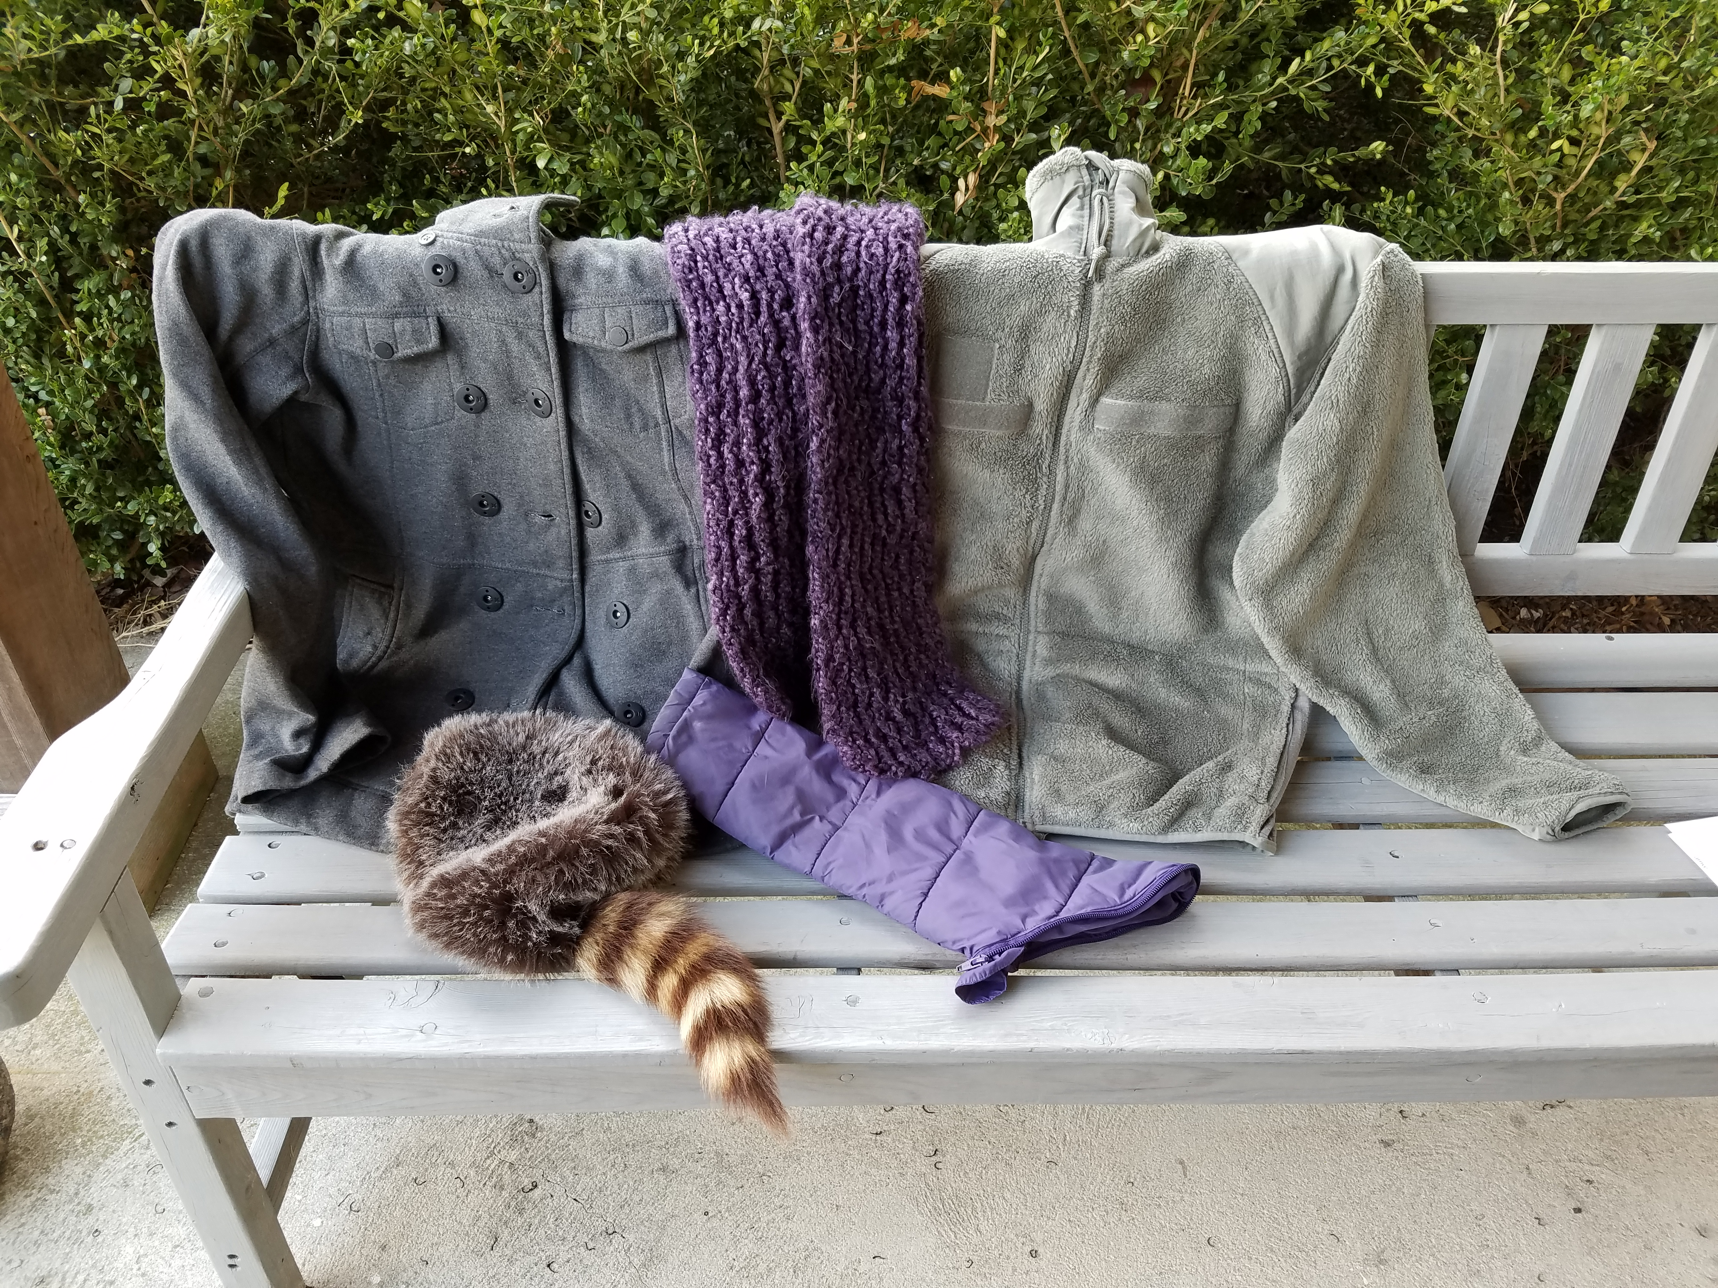
Do Any of These Belong to You? Purple zip-off sleeve from a child’s coat; long, purple knitted scarf left at Jackie’s after winter study; adult’s grey fleece zip-up; child’s dark grey button-up jacket; coonskin cap. Call church office. 6140

Open Apiary Day: I plan to hold an open apiary day from time to time, for people to come over and see inside the hives. Send me an email if you are interested, and I will notify you when I make a date. Space is limited, and times will be weather-dependent. I will let you know more specifics in an email.
– Suzanne Evans (suzevans@fast.net)
News from the Stony Run Inn
Live Music: It’s our great pleasure to feature two of our favorite local musicians (who will be performing here again in April if you can’t make the following shows).
Kai Kaysen (our own Kempton Postmaster) – Friday, March 17 (6—8 P.M.)
Stephanie Eden (the Lovely and Talented) – Friday, March 24 (6—8 P.M.)
- Reservations are a must. Our tables fill up fast. Call 610-756-4433.
Official Beer Garden Opening: Friday, May 5 (will remain open into October). Last summer, Cade Cole and his team did a stunning job of creating an outdoor deck for us. We plan to develop the space further throughout the coming summer. Come enjoy it!
Help Wanted: The Stony Run Inn is continuing to grow, requiring us to hire more dishwashers and servers. We seek hard-working, responsible people age 16 and above. No experience necessary. On-the-job training provided. Anyone interested in supplementing their income or looking for an after-school or summer job, please call Austin Grant at 610-756-4433.
Small Kempton Cottage for Rent. Available April 1 or May 1. Please call Curtis or Mary McQueen. 610-756-6604

